
THE G8 EXAMINATION
Kenya Certificate of Secondary Education
FORM 4 TERM 2- JUNE 2026
312/2
GEOGRAHY
PAPER 2
MARCH 2026
TIME 2^{3/4}HOURS

MARKING SCHEME

SECTION A: Answer ALL questions in this section
1. (a) Define the term environment. (2marks)
Environment is all external conditions that surround an organisms/ external conditions that influence the development and behavior of an organism.
(b) List three sub- divisions of human and economic geography. (3marks)
- Historical geography
- Cultural geography
- Demographic geography
- Political geography
- Social geography
- Settlement geography
- Economic geography (first 3x1=3marks)

2. The diagram below shows shaft mining
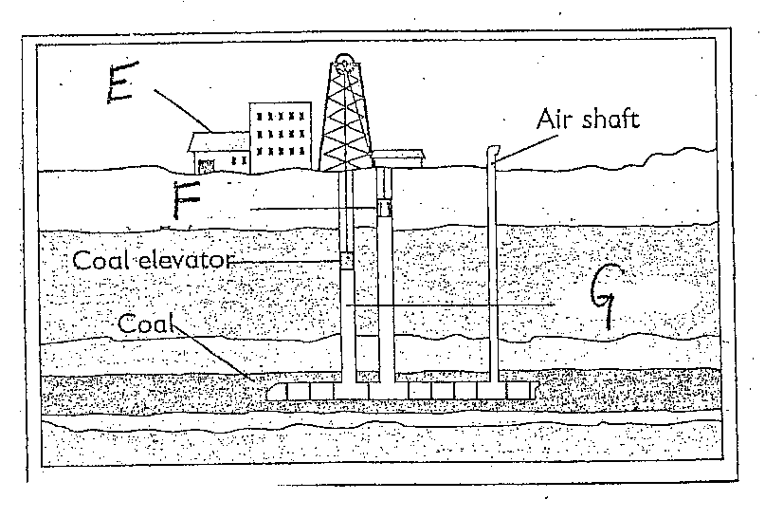
(a) Name the parts marked E, F and G. (3 marks)
E-preparation plant F-cage/lift G-vertical shaft.
(b) State two problems associated with shaft mining. (2 marks)
- Sometimes mines get flooded with sub-terrain water.
- There are occasional emission of poisonous gases in the mines.
- The dust produced causes respiratory diseases.
- Sometimes tunnel collapse causing deaths of the miners. (first 2x1=2marks)
3. (a) Differentiate between horticulture and market gardening. (2 marks)
Horticulture is a farming practice where fruits, vegetables and flowers are grown mainly for external markets while market gardening is the intensive cultivation of vegetables and fruits for sale in the nearby urban centre..
(b) State three factors that have influenced the growth of horticulture farming around Lake Naivasha. (3 marks)
- Availability of water from the lake used to irrigate farms.
- The soil near the lake is deep, fertile and well drained idea l for horticultural crops.
- Well Developed transport networks eg Naivasha-Nairobi road, Naivasha-Nakuru road and Olkaria road linking the farms to markets.
- The sunny weather condition from the area farm favours the growth of crops.
( first 3x1=3marks)
4. (a) Differentiate fishing and fisheries. (2 marks)
- Fishing is the exploitation of water resources/ aquatic animals like fish while fisheries are the water bodies that contain fish and other related resources.
(b) State three similarities between fishing in Kenya and Japan. (3 marks)
- Both counties carry out inland and marine fishing
- In both countries the fish caught is consumed both locally and exported
- In both countries the government promotes fishing through legislation /research /conservation
- There is overexploitation of fisheries in both countries (first 3x1=3marks)

5.(a) What is ecotourism (1mark)
Eco-tourism is the development and management of tourism while conserving the environment/ It is enjoying what nature provides while protecting it.
( b) Give four Characteristics of Eco-Tourism in kenya. (4marks)
-The tourists follow marked trails instead of driving to the areas where animals are. -Telescopic viewing of the animals is encouraged. -There is creation of awareness among the local communities to appreciate and understand nature. - Benefits accrued are shared with the community. -Mass tourism is being discouraged. Mass tourism is where large group of people in several vehicles visit game parks and occasionally surround animals of interest interfering with their routines. -Soft or green tourism is being encouraged. This is where people travel seeking to protect and restore the damaged environment e.g. by planting trees. -At the entry points to the parks, tourists are warned against dangers of throwing cigarettes remains onto dry vegetation. -Only particular types of vehicles are allowed in parks. (first 4x1=4marks)
SECTION B:Answer question 6 and any other TWO questions from this section.
6.The table below shows the methods used in land reclamation by sub counties in Kenya in the year 2022. Use it to answer (a)
METHOD OF LAND RECLAMATION | NUMBER OF SUB COUNTIES
Irrigation | 70
Drainage of swamps | 80
Tsetse fly control | 45
Afforestation | 15
Others | 30
TOTAL | 240

(a)i) draw a divided rectangle measuring 15 cm to represent above data (8marks)
calculations.
Irrigation=(70/240) 15cm = 4.4cm
Drainage of swamps =(80/240)15cm=5.0cm
Tsetsefly control=(45/240)15cm=2.8cm
Afforestation= (15/240)15cm= 1.0cm
Others =(30/240)15cm=2.0cm

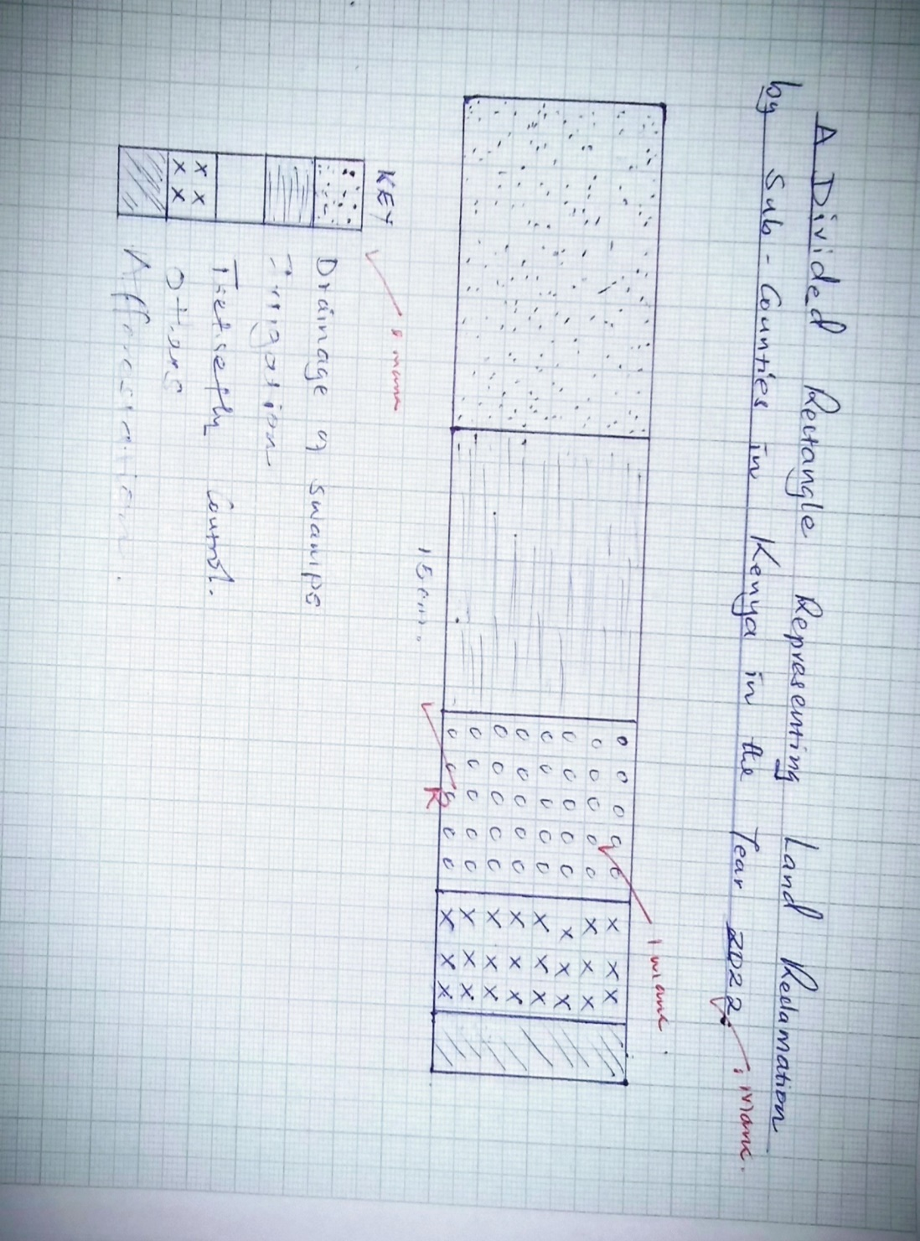

Calculation each 1mk x4= 4marks
Title 1mark
Key 1 mark
Rectangle 2 marks total = 8marks
(ii)State two disadvantages of using the above method to present the data . (2 marks)
- -Time consuming while drawing the graph.
- Represents a few variables/ items.
- Values cannot be read at a glance.
(first 2x1=2marks)
(b)(i)Name two rivers that supply water to the Mwea Tebere irrigation scheme. (2 marks)
  - river Thiba
  - river Nyamindi
  - river Murubara (first 2x1=2marks)
(ii)Explain how the following factors influenced the establishment of the Mwea Tebere Irrigation Scheme:
topography; (2 marks)
-The gently sloping land makes it possible for water to flow by gravity into/out of the irrigated fields.
-The gently sloping land allows for mechanization which allows large areas to be put under cultivation.
(any 1 × 2 = 2 marks )
Soils (2 marks)
- Presence of black cotton soil which retains water for a long time suitable for cultivation of rice
- Presence of loamy soils ensured cultivation of other crops to support the families settled.
(any 1 × 2 = 2 marks )
(c)(i)Name three polders which make up the Zuider Zee reclamation project in the Netherlands. (3 marks)
- Markerwaad
- Wieringer meer
- South Flevoland
- East Flevoland
- North- Eastern Flevoland (first 3x1=3marks)
(ii) Give three differences between land reclamation in Kenya and the Netherlands. (6 marks)
- In Kenya, the area that is reclaimed is relatively small while the areas reclaimed in the Netherlands are large.
- In Kenya, land is mainly reclaimed from swamps and marginal areas while in Netherlands reclamation is from the sea.
- In Kenya, the methods used for draining water from marshy areas is digging of canals/ditches while in the Netherlands the methods are advanced/use of wind pumps to drain sea water from the polders.
- In Kenya, irrigation is used as a means of reclaiming dry areas while irrigation in the Netherlands is used to lower the salinity of the soil in the reclaimed lands.
- Furrow/ ridges in Kenya are used to control river floods while in the Netherlands, dykes protect the reclaimed land from invasion by the sea.
- In the Netherlands, the methods employed are more capital intensive while in Kenya, the methods are less capital intensive.
- In the Netherlands, the main method of land reclamation is the draining of the seas while in Kenya a variety of methods are used e.g. irrigation/ tse tse fly control.
- In the Netherlands, advanced technology are employed in reclaiming land e.g. use of underground pipes/ pumping stations while in Kenya, low technology that uses only canals and dykes.
. (first 3x2=6marks)
7.(a)(i)list two indigenous softwood trees found in Kenya. (2 marks)
- African pencil Cedar /juniperous procera.
- Podo /podocarpus/East African yellow wood
- Bamboo. first 2 x 1 =(2 marks)
(ii) State three factors that favour the development of softwood forests in Kenya. (3 marks)
-Cool climate enables coniferous to grow/ flourish -Highlands receive high amount of rainfall -Rugged highlands discourage settlement and agricultural activities leaving forestry as the alternative -High demand for the softwood products encourage tree planting -Deep soils favour forest growth -Softwoods grow quite first due to warm conditions first 3 x 1 =(3 marks)

(iii) Give three differences between forestry in Kenya and Canada (3 marks)
- In Kenya, softwood forests grow faster due to high temperatures while in Canada, softwood forests grow slowly due to low temperatures.
- In Kenya, harvesting of trees is done selectively while in Canada, clear/ indiscriminate cutting of trees is done.
- In Kenya, forest products are mainly sold locally whereas forest products in Canada are mainly exported.
- In Kenya, logs are transported by road/ trucks while in Canada transport is mainly by water/ by rivers. - In Kenya, transportation is expensive while in Canada it is cheap.
- In Kenya, softwood forests are found mainly in the highlands while in Canada they are found both in highland and lowland areas.
- In Kenya, harvesting of trees is done throughout the year while in Canada, harvesting is done in winter and early spring.
- In Kenya, there are both exotic (cypress,wattle) and indigenous (podo and African pencil) tree species while in Canada, all tree species are indigenous e.g. spruce.
- In Kenya, logs in the sawmills are debarked using very strong flow of high pressure water then converted into useful products while in Canada, logs in the sawmills are debarked, then cut into large boards then converted into useful products.
- In Kenya, there is a problem of heavy logs and poor transport networks that inhibit exploitation while in Canada, some parts are not accessible in winter due to very cold climate and ruggedness of terrain inhibiting exploitation. first 3 x 1 =(3 marks)
(b) State three ways in which clearing of forests has affected natural environment in Kenya.
(3 marks)
- Has led to reduced volume of water in the rivers/ caused drying up of rivers.
- Has led to destruction of natural habitat for wildlife.
- Has led to changes in the rainfall pattern/ desertification.
- Has interfered with the beauty of the environment.
- Has disrupted the ecosystem.
- Has accelerated soil erosion first 3 x 1 =(3 marks)
(C)Explain four problems facing exploitation of tropical rainforests in Africa. (8 marks)
- Wide variety of tree species hence exploitation of valuable species is difficult
- Valuable tree species widely scattered hence difficult / expensive to exploit
- Thick/ dense undergrowth hinder accessibility hence difficult / expensive to exploit
- Presence of Dangerous wild animals pose direct threats to labourers/ work may be delayed/restricted to daylight hours/ require armed security increasing overhead costs.
- Heavy rainfall all year round makes most road impassable
- Bulkiness of logs which makes transportation difficult first 4 x 2 =(8 marks)
(d)A form four class conducted a field study in a forested region in the area around their school.
(i)Identify two main categories of hypotheses that the students would have formulated.(2 marks)
- null hypothesis/negative hypothesis
- alternative /substantive /positive hypothesis 2 x 1 =(2 marks)
(ii)Give four activities that the students would have been involved in during the study. (4 marks)
- Identifying the trees by their local / botanical names.
- Finding out the trees that are hardwood / those that are softwood
- Finding out the uses of trees / forest products.
- identifying the trees that are indigenous / those that are exotic
- Finding out the problems facing the trees in the region. first 4 x 1 =(4 marks)
8.(a) Name two types of dairy cattle kept in Kenya. (2 marks)
- Friesian/Holstein
- Guernsey
- Jersey
- Ayrshire
- Sahiwal
- Alderney
- The Channel Island cows first 2 x 1 =(2 marks)
(b) (i) State four human factors that favour dairy farming in Rift Valley. (4 marks)
- Availability of labour/market from the high population.
- Presence of milk processing factories in the region.
- Well developed transport network in the region.
- Presence of milk cooperatives in the region.
- Availability of extension/ veterinary services for the farmers. first 4 x 1 = (4 marks)
(ii) State three problems facing dairy farmers in Kenya. (3 marks)
- Small scale dairy farms face stiff competition from other cash crops like tea
- Very high cost of inputs which has minimized mechanization and resulted into to low profit margins.
- Impassable roads during the rainy season making milk delivery difficult hence spoilage.
- Drought/unreliable rainfall which result in inadequate pastures which causes temporary milk shortage.
- Risk of cattle pests like ticks/Tse tse fly and Diseases like east coast fever which affect dairy animals lowering yield.
- Poor management of dairy co-operatives at grassroots resulting to delayed payments which kills farmers’ morale.
- Shortage of proper storage facilities at the collecting centres such as cooling plants causing milk to go bad before it gets to processing factories leading to losses for farmers.
- AI services have been privatized making them very expensive/ inaccessible to many small-scale farmers resulting in low quality breeds and hence low milk production.
- Fluctuating milk prices/low prices make farmers unable to plan ahead.
- Inadequate capital to purchase farm inputs hence limit dairy farming in large scale.
first 3 x 1 = (3 marks)

(c) (i) Give three measures the government of Kenya is taking to improve dairy farming.
(3 marks)
- Appointing supervisory boards for dairy co-operatives.
- Extending credit facilities to farmers through co-operatives.
- Holding agricultural shows to educate farmers on good dairy farm management.
- Setting up demonstration farms which breed high quality bulls to be released to farmers.
- Establishing well maintained roads for delivery of milk.
- Carrying out extensive research on possible solutions to diseases first 3 x 1 = (3 marks)

(ii) Explain four ways in which dairy farming in Kenya is different from dairy farming in Denmark.
(8 marks)
- In Kenya, cattle mainly depend on naturally growing grass/pasture whereas in Denmark, the cattle is fed on fodder/commercial grass/commercial feeds.
- In Kenya, mechanization is limited/mainly labour intensive while in Denmark, mechanization is widely used.
- In Kenya, most farmers practice mixed farming while in Denmark dairy farming is highly specialized.
- In Kenya, most of the dairy products are consumed by the domestic market while in Denmark, the products are mainly exported.
- In Kenya, dairy production is affected by variation in climate while in Denmark dairy farming is least affected by variation in climate.
- In Kenya, dairy cooperatives are least developed while in Denmark, dairy cooperatives are highly developed.
- In Kenya artificial insemination/extension services is limited to a few farms while in Denmark, artificial insemination/extension services is widely used.
- In Kenya animals graze outdoor throughout the year while in Denmark, animals are kept indoor during winter.
- In Kenya research is limited while in Denmark research is extensive.
- In Kenya, dairy farming is practiced in highlands while in Denmark it is found throughout the country. first 4 x 2 =(8 marks)
(d) You intend to carry out a field study in a dairy farm.
(i) Give two methods you would use to collect information. (2 marks)

- tape recording
- filling in questionnaires
- taking photograph
- taking notes
- tallying
(first 2x1 = 2mks)
(ii) State three follow up activities you would carry out after the field study. (3 marks)
- Analysing the data collected.
- Giving lecture.
- Interpretation
- Discussing the findings.
- Writing reports.
- Displaying photographs
- Drawing graphs (any 2x1 = 2mks)
9. (a) (i) Name two renewable sources of energy. (2 marks)
- Water
- Wind
- Sun
- Waves/ tides
- Geothermal steam/ underground steam
- Biomass
- Wood / trees
- Drought animals (any first 2 x 1 = 2 mks)
ii) State three advantages of using Hydro-Electric power (3 marks)
- It is inexhaustible / renewable.
- It is clean / environmentally friendly.
- It can be transmitted over long distances using cables.
- It can be put into many uses e.g. cooking, lighting
- It is relatively easy to use i.e. switching on/ off.
- Dams for HEP creates lakes used for fishing / irrigation/ recreation.
- It is reliable since significant levels of energy are produced. (any first 2 x 1 = 2 mks)
(b)Explain four Physical factors that favoured the development of the seven forks hydro-electric power projects.
(8 marks)
- Presence of large volume of water from River Tana and its tributaries to provide water to drive the turbines.
- Regular/ constant flow of River Tana which enabled continuous production of electricity.
- Presence of hard basement rock along the site which provided a firm foundation for the dams.
- Availability of enough space for construction of dams / reservoirs due to low population in the area.
- Presence of waterfalls / rapids/ steep gradient which provided sufficient hydraulic force to turn the turbines.
- Presence of impervious rock which prevents seepage of water underground.
- Presence of a gorge / deep valley which reduced the cost in construction of dam.
- (any first4 x 2 = 8 mks)
(c) (i) Define the term energy crisis. (2 marks)
- Energy crisis refers to a situation where the prices of fossil fuels rise uncontrollably as a result of short supply relative to demand
(ii) State four ways in which energy crisis affect the Kenya economy. (4 marks)
- Increase in oil prices triggers increase in prices of commodities/ inflation leading to low standards of living/ high cost of living.
- Increase in oil prices leads to rise in the cost of farm inputs which in turn leads to low agricultural production/ food shortage.
- Increase in prices of crude oil makes Kenya spend a lot of foreign exchange in importation lowering foreign currency reserves / brings about imbalance of trade/ slows down the rate of economic growth.
- Increase in oil prices leads to high cost of production leading to slow industrial growth.
- Oil scarcity leads to scarcity of by-products of oil leading the scarcity of raw materials in some industries.
- Increase in fuel prices leads to an increase in transport costs which triggers price increase in price commodities/ inflation/ reduced tourism activities.
- Increase in oil prices leads to high demand for wood fuel leading to deforestation.
- Increase in oil prices has led to the development of alternative sources of energy to reduce overdependence of oil.
( first 4 x 1= 4 marks)
d)( i) Differentiate between Management and Conservation of Energy . (2 marks)
- Management of energy is the effective planning and control of energy resources while Conservation of energy is the careful use and protection of energy resources to ensure little/ no wastage.

(ii)State four Measures the government of Kenya has taken to conserve energy (4 marks)
- Encouraging people to use renewable sources of energy in order to reduce the overreliance of fossil fuels.
- Developing energy saving technologies in order to reduce the high consumption of energy.
- Enforcing the legislation against indiscriminate cutting down of trees for fuel thus conserving existing resources.
- Educating the public on the careful use of energy in order to save it.
- Progress taxation on energy consumption in order to discourage the misuse of energy.
- Proper planning of road networks in urban areas to reduce traffic jam hence saving on fuel consumption.
- Encouraging the use of public transport/ walking/ cycling/ railway in order to reduce the number of vehicles on the roads/ reducing energy consumption.
- Discouraging importation of high fuel consumption vehicles to reduce amount of fuel used.
- Encouraging afforestation/ reafforestation for continuous supply of wood fuel.
( first 4 x 1= 4 marks)
10. (a) (i) Name two towns in Kenya with motor vehicle assembly industries. (2 marks)
- Thika
- Nairobi
- Mombasa. ( first 2 x 1= 2 marks)
(ii) State four ways in which Kenya has benefited from the motor vehicle assembly industries. (4 marks)
- Kenya saves foreign exchange due to reduced importation of vehicles.
- Kenya earns foreign exchange through exportation of assembled vehicles.
- Created employment opportunities.
- Promoted trade links with neighbouring countries.
- Promoted transport system by providing buses and lorries.
- Source of government revenue through taxation.
- Allowed transfer and development of technical skills among Kenyans. ( first 4 x 1= 4 marks)

b) What efforts have been made to decentralize industries in Kenya? (3 marks)
- Improving security in the rural areas.
- Providing cheap land for industrial sites.
- Constructing roads in the rural areas to make them accessible.
- Offering tax relief/ reduced taxes/ tax waivers to attract investors.
- Giving subsidies to reduce cost of production.
- Encouraging rural electrification. ( any 3 x 1= 3 marks)
c)i) Apart from iron and steel industry name two other industries within the Ruhr region of Germany.
- Textiles industry.
- Oil refining.
- Electronic industry.
- Food processing.
- Cutlery making.
- Pharmaceutical industry.
- Chemical/petrochemical industries. ( first 2 x 1= 2 marks)
ii) Explain four factors that led to the development of iron & steel industry in the Ruhr Region of Germany. (8 marks)
- Availability of coal /iron ore /limestone from the Rhine valley provided raw materials needed in the industry.
- Presence of rivers Rhine /Ruhr/ Lippe provided water required for industrial use e.g. cooling of machines.
- Presence of navigable Rhine /Ruhr Rivers / EMS canals provided cheap water transport for the bulky raw materials/finished products.
- Coal from Ruhr region/imported petroleum provided power required in the industry.
- The local population had acquired skills on iron working this formed the foundation of iron and steel industry.
- Presence of rich companies /families like Ruhr krupp which provided capital for the development of industries.
- The region is centrally located in Europe which offers easy access to all parts of the Europe.
- The dense and affluent population in (central and western) Europe/Germany provided ready market for iron and steel. ( first 4 x 2= 8 marks)
d) Your class has decided to undertake a field study in a Jua Kali near your school.
i) State three problems facing Jua Kali industry you are likely to identify. (3mks)
- Shortage of power slows down production.
- Inadequate capital to purchase raw materials.
- Difficulty in getting raw materials.
- Competition from imported products reduces the market for goods.
- Competition from other well established industries for raw materials / market.
- Inadequate marketing skills/ strategies.
- Negative attitude of Kenyans towards Jua Kali goods/ feeling of inferior reduces market.
- ( first 3 x 1= 3 marks)
- State three importance of a work schedule during fieldwork. (3mks)
- It helps in carrying out the field activities systematically.
- It helps in estimating the total time required for the study.
- It ensures all areas of study are adequately covered.
- It helps in assessing progress of the study.
- It enables proper use of available time.
- It confines one to the scope of the study. ( first 3 x 1= 3 marks)

